HAPPENING NOW: Panel Discussion “Faith Communities in Partnerships to address COVID-19.” Watch this thread for live updates!

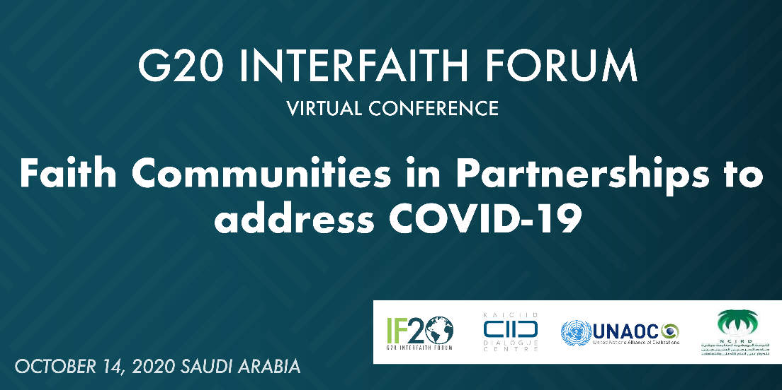

"In large measure, religious leaders worldwide have acted with compassion, insight, and responsibility with respect to the various responses to the COVID-19 #pandemic."

- Rev. Prof. James Christie of the Canadian Multifaith Federation

#G20Interfaith

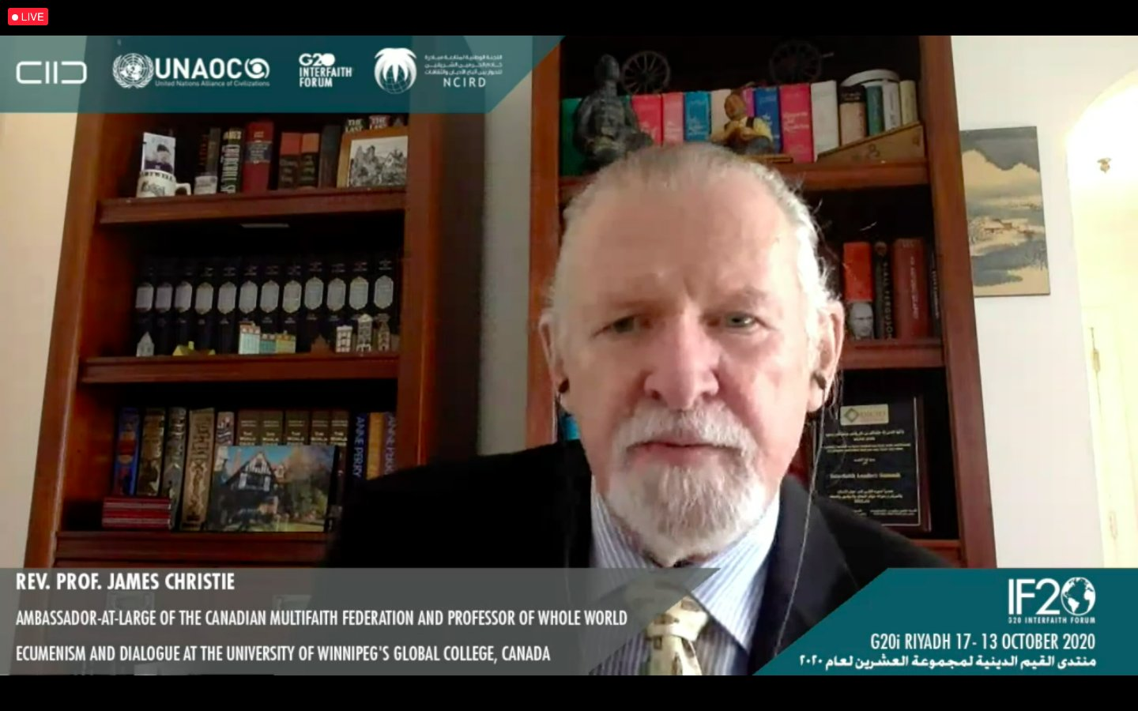

"If we want to achieve universal #health coverage, it will be essential to integrate faith communities into the worldwide global environment."

- @jfdelavison of @AhimsaFund

#G20Interfaith

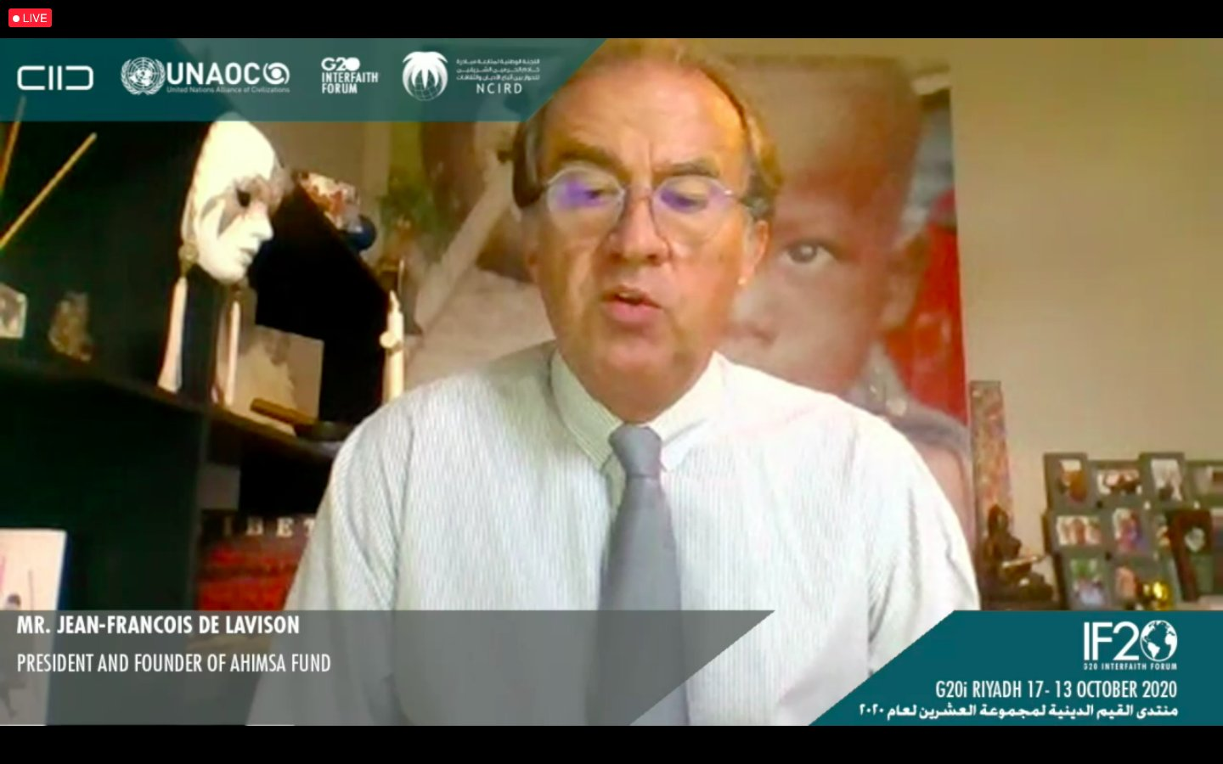

“We would like to recognize faith communities as an integral part of emergency response. Faith communities are a part of resilience and building social cohesion.”

- @hess_se of @WHO

#G20Interfaith

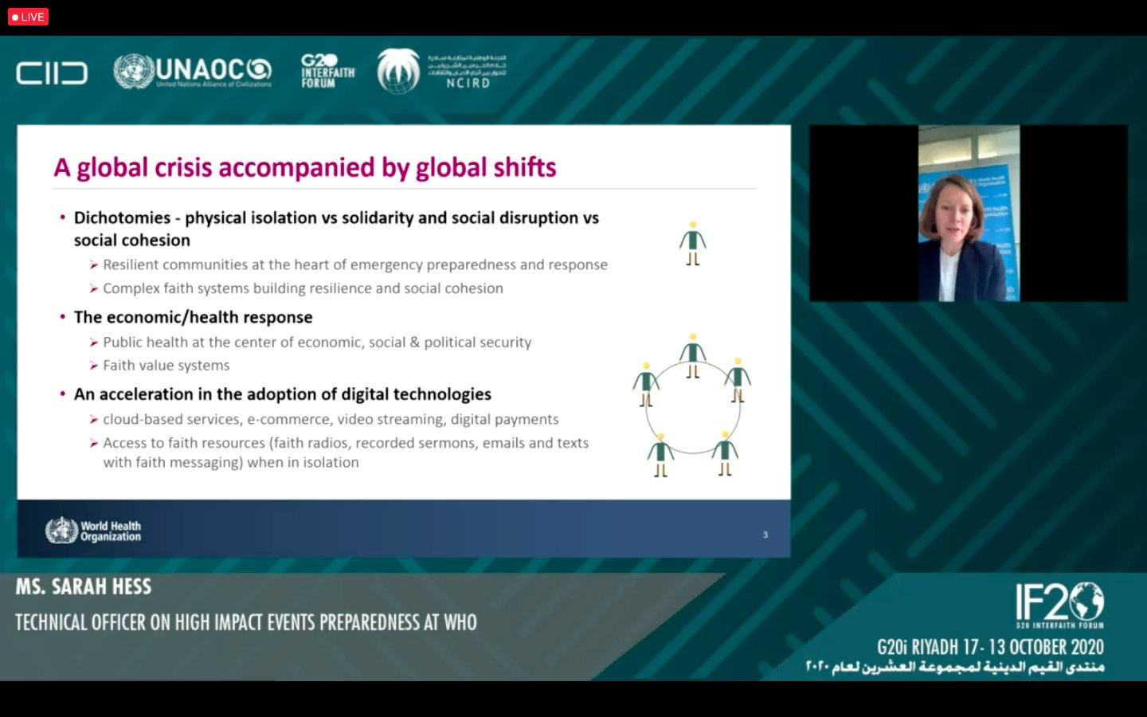

“Faith communities have to be acknowledged and partnered with as laboratories of a human centered artificial intelligence…we need to bridge the gap between #innovation and #religion.”

- Prof. Marco Ventura of @unisiena

#G20Interfaith

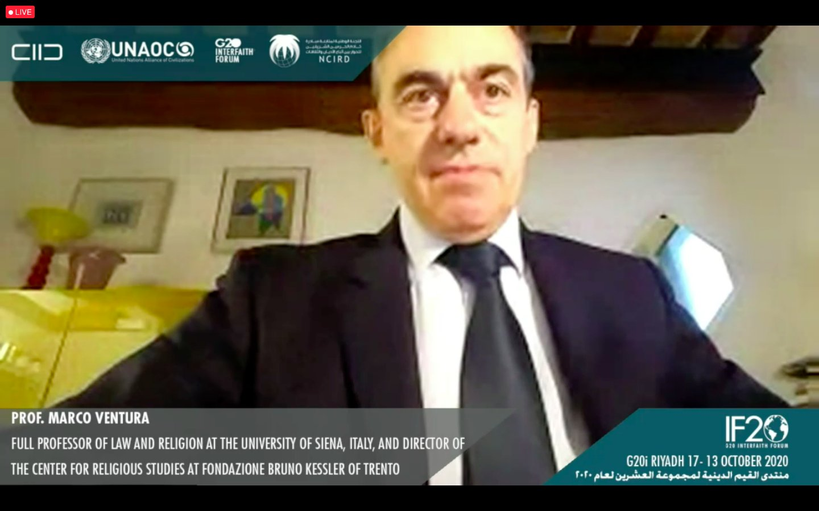

“Religious actors need training and need to be included in the structural responses to #disasters.”

- @naomikalish of @KAICIID

#G20Interfaith

