HAPPENING NOW: Panel Discussion “Refugees and Migrants with Focus on Women and Youth.” Watch this thread for live updates!

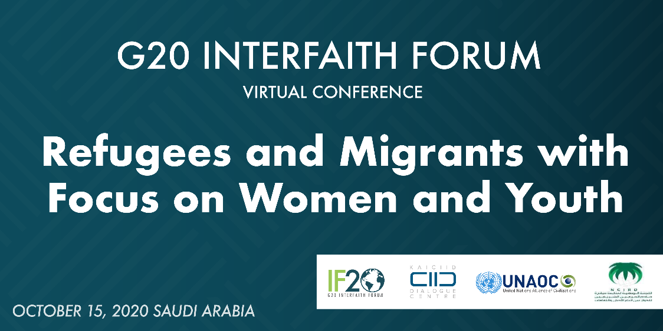

"We need to do our best to do #relief work but also to provide psycho-social support, to teach and raise awareness to try and limit the bad influence of the situation on the #refugees.”
- Sheikh Mohamad Abou Zeid of the Family Court of Saida in Lebanon
#G20Interfaith
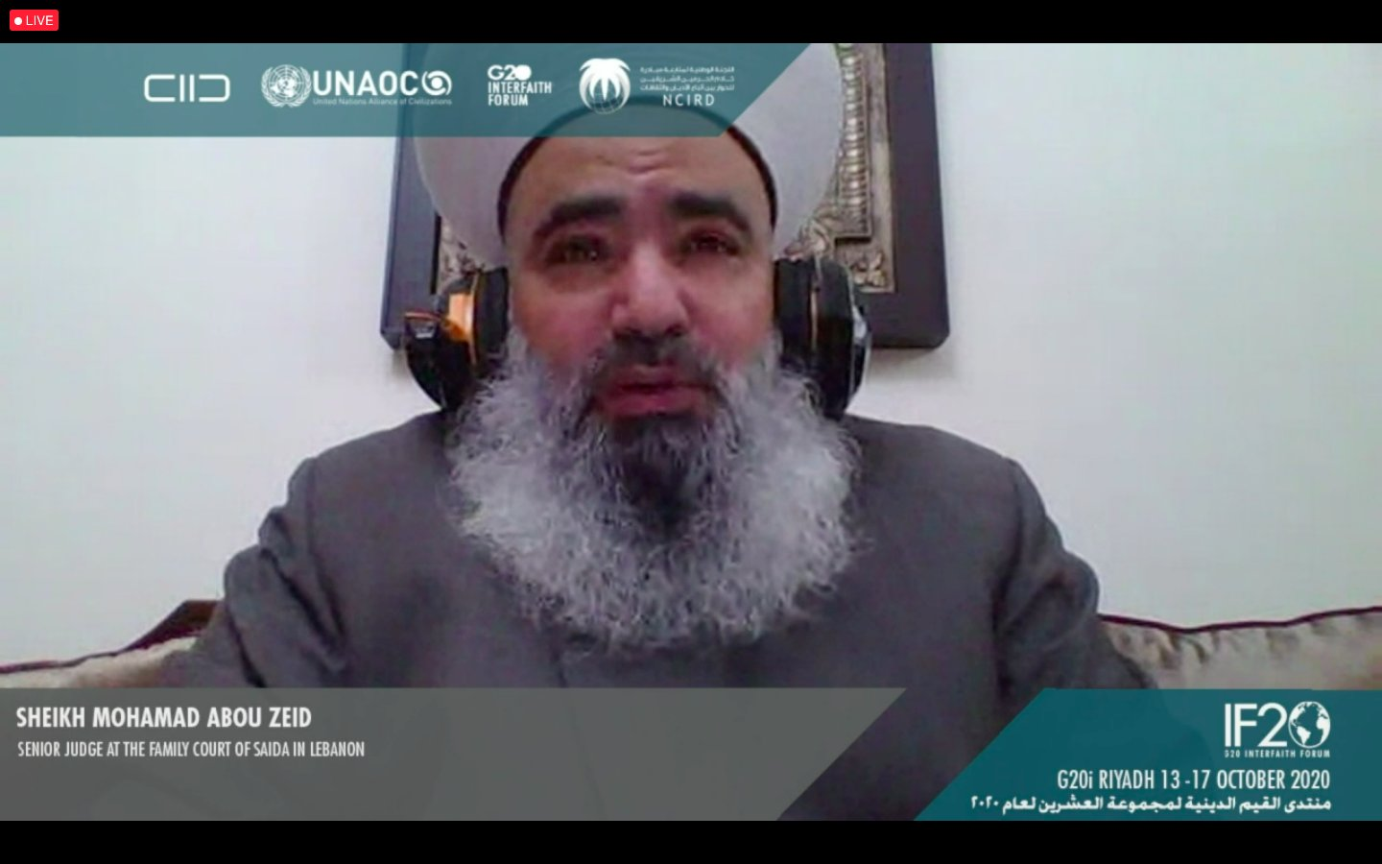

“Religious communities can encourage greater responsibility in meeting the needs of #women and #children, creating channels for meaningful engagement. Recommendations from religious communities are essential.”
- Dr. Pritpal Kaur Ahluwalia of @religions4peace
#G20Interfaith
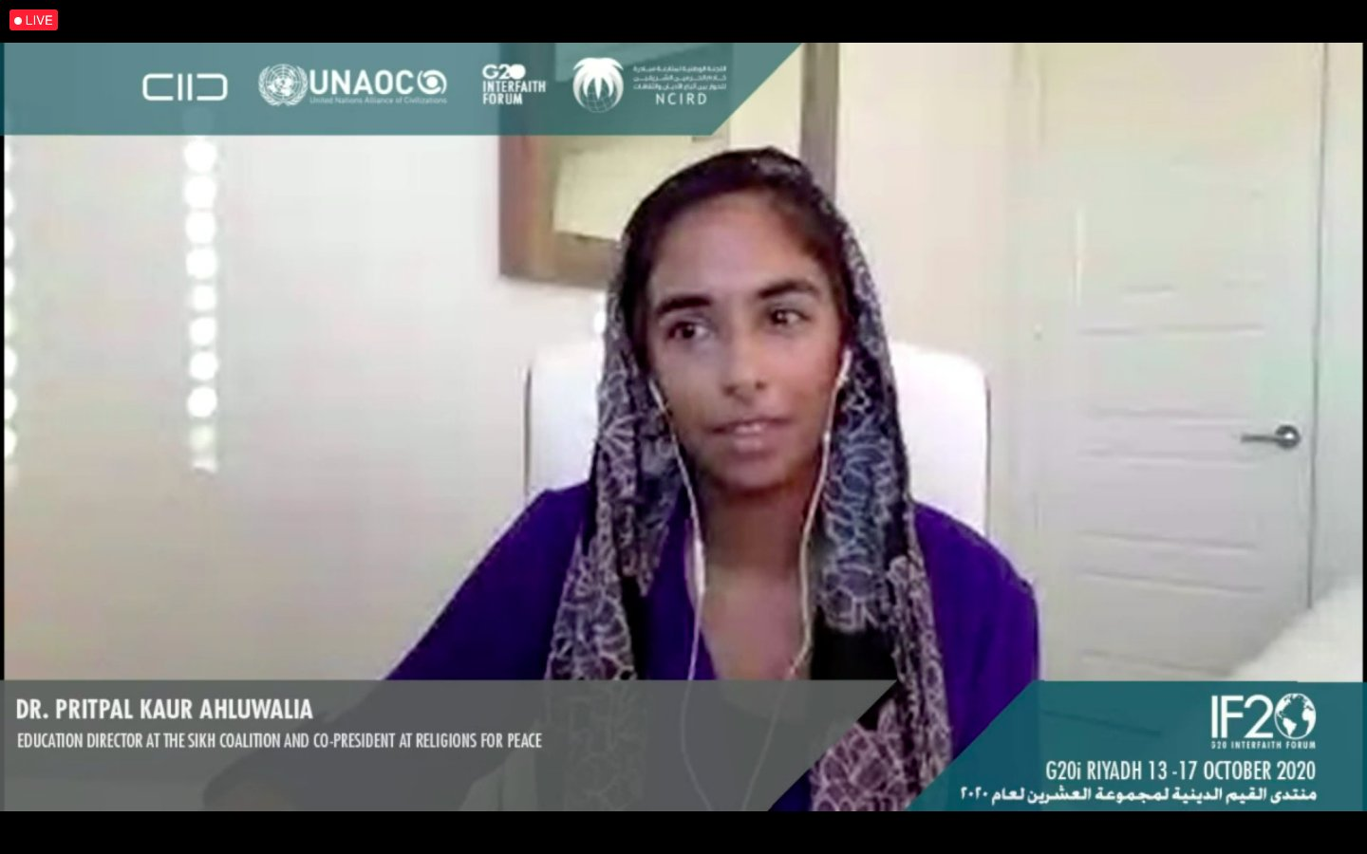

“We’ve learned that working with faith actors, helping them to articulate how faith relates to child #wellbeing is really powerful, since they advise parents and even children on health.”
- @SowEsther of @WorldVision
#G20Interfaith
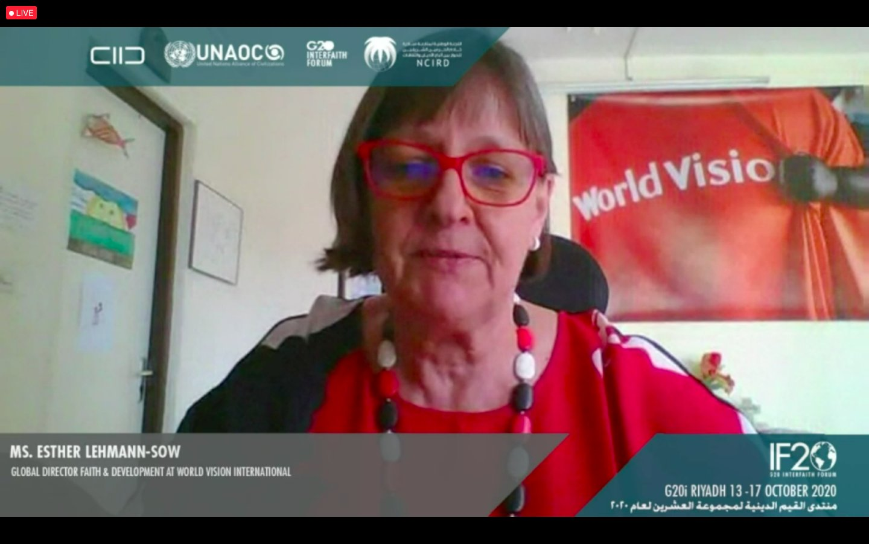

“In any effort that aims to assist social integration of migrants, especially #women, enhancing #education, decreasing gender-based #violence, and promoting equal #employment opportunities are three key issues.”
- @AnoudAlofaysan of @Salam4ccAR
#G20Interfaith
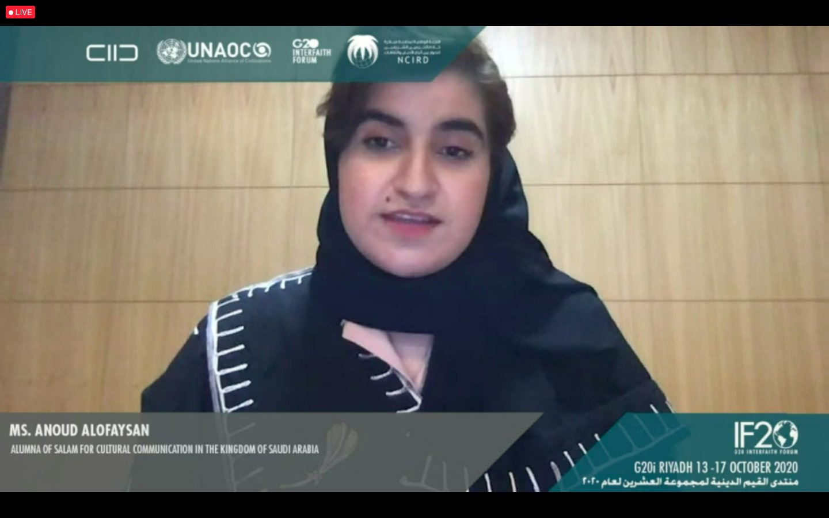

“I think it is a promising time for faiths. It is promising that there are huge ramifications when faiths come together with the constituents that they have to influence #policy.”
- Imam Sayed Ali Abbas Razawi of @S_A_B_S_
#G20Interfaith
